Chapter 7 Taxes:
Name:
Class Hour:
Web Project Directions: You must use one of the computers in Mrs. Vetter’s lab as you will be printing and attaching items to this packet. Use the internet and answer the following questions:
- When must taxes be filed by?
- Who must File taxes? List 2 – 3 answers:

- There are 2 forms available to use to file your taxes. Some people use a 1040 while others use the 1040-SR. Using the internet, find “Who can use each form”. Give a brief description in the spaces below of who can use each of these forms:
Who uses a 1040 – SR:

Who use a 1040

- What are the five types of filing statuses available?
- What is your current filing status? What form would you use?
- All forms and directions (change yearly) are available for citizens to access online at the IRS.gov site. Go to the internet and find the instructions for completing the 2020 1040. Enter the URL here:
- Find a form 2020 1040 and print it. Staple it to this packet. This must be printed or you will not be able to complete the next section of the notes.
- Use google and find what is a standard deduction? Enter the definition here:
- Based on the 2020 Tax rates, what is the stand deductions for the following status:

Single
Married, filing jointly
Married, filing separately
Head of household

You are complete with the Web Project. The following is from Lecture with instructor.
To file your taxes you will need a form which must be mailed to you by employers by what date? ? On the W2, when filing your federal income tax, you will use which boxes? . Box 1 lists the amount of you earned for the entire year. Box two lists what information?

Gross Income | Adjustments:
List Type & Form Used: | List Items that are non-taxable

When you file, you can reduce your taxable income by using either a deduction or
deductions. Use the one that is the in value.
Standard deductions:

Itemized deductions:

Examples:

Work Together on the 1040 you attached
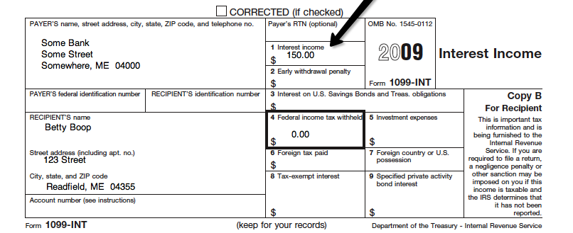

Calculating what you owe in taxes:
Steps:

